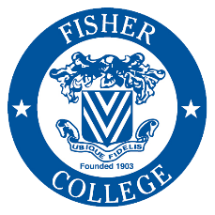
FISHER COLLEGE
Gainful Employment Disclosures
2019

Program Name Medical Assistant

This program is designed to be completed in 12 months.

This program will cost $15,451, if completed within normal time. There may be additional costs for living expenses. These costs were accurate at the time of posting, but may have changed.

Of the students who completed this program within normal time, the typical graduate leaves with N/A of debt. **Fewer than 10 students completed this program within normal time. This number has been withheld to preserve the confidentiality of the students.

The following States do not have licensure requirements for this profession: Alabama, Alaska, American Samoa, Arizona, Arkansas, California, Colorado, Connecticut, Delaware, District of Columbia, Federated States of Micronesia, Florida, Georgia, Guam, Hawaii, Idaho, Illinois, Indiana, Iowa, Kansas, Kentucky, Louisiana, Maine, Marshall Islands, Maryland, Massachusetts, Michigan, Minnesota, Mississippi, Missouri, Montana, Nebraska, Nevada, New Hampshire, New Jersey, New Mexico, New York, North Carolina, North Dakota, Northern Marianas, Ohio, Oklahoma, Oregon, Palau, Pennsylvania, Puerto Rico, Rhode Island, South Carolina, South Dakota, Tennessee, Texas, Utah, Vermont, Virgin Islands, Virginia, Washington, West Virginia, Wisconsin, Wyoming.
For more information about graduation rates, loan repayment rates, and post-enrollment earnings about this institution and other postsecondary institutions please click here: https://collegescorecard.ed.gov/

